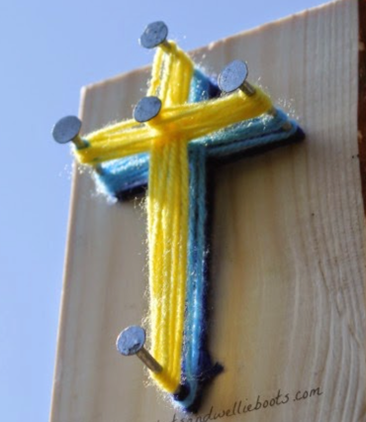
Simple String Art - Weaving an Easter Cross

To make these Easter Crosses use:
A small block of wood
5 Nails (40mm) for each cross
Colored yarn/string
Hammer
Ruler, scissors & pen

Using the ruler mark out a cross shape in the center of the wooden block to clearly see where to add the nails. Hammer the nails into the four points of the cross, and one into the center. Start by taking a length of yarn & securing it around one of the nails. To create the cross shape just loop the yarn around the nails & weave it in & around each one. It is easier to do the center of the cross first, just weaving up & down in one direction, & then moving from the center nail to the arms of the cross. You can add different colors by securing the lengths of the previous yarn to the new one & continue weaving. As your weave gets a little thicker, gently pushing down the yarn to free up a little more space on the nails.
