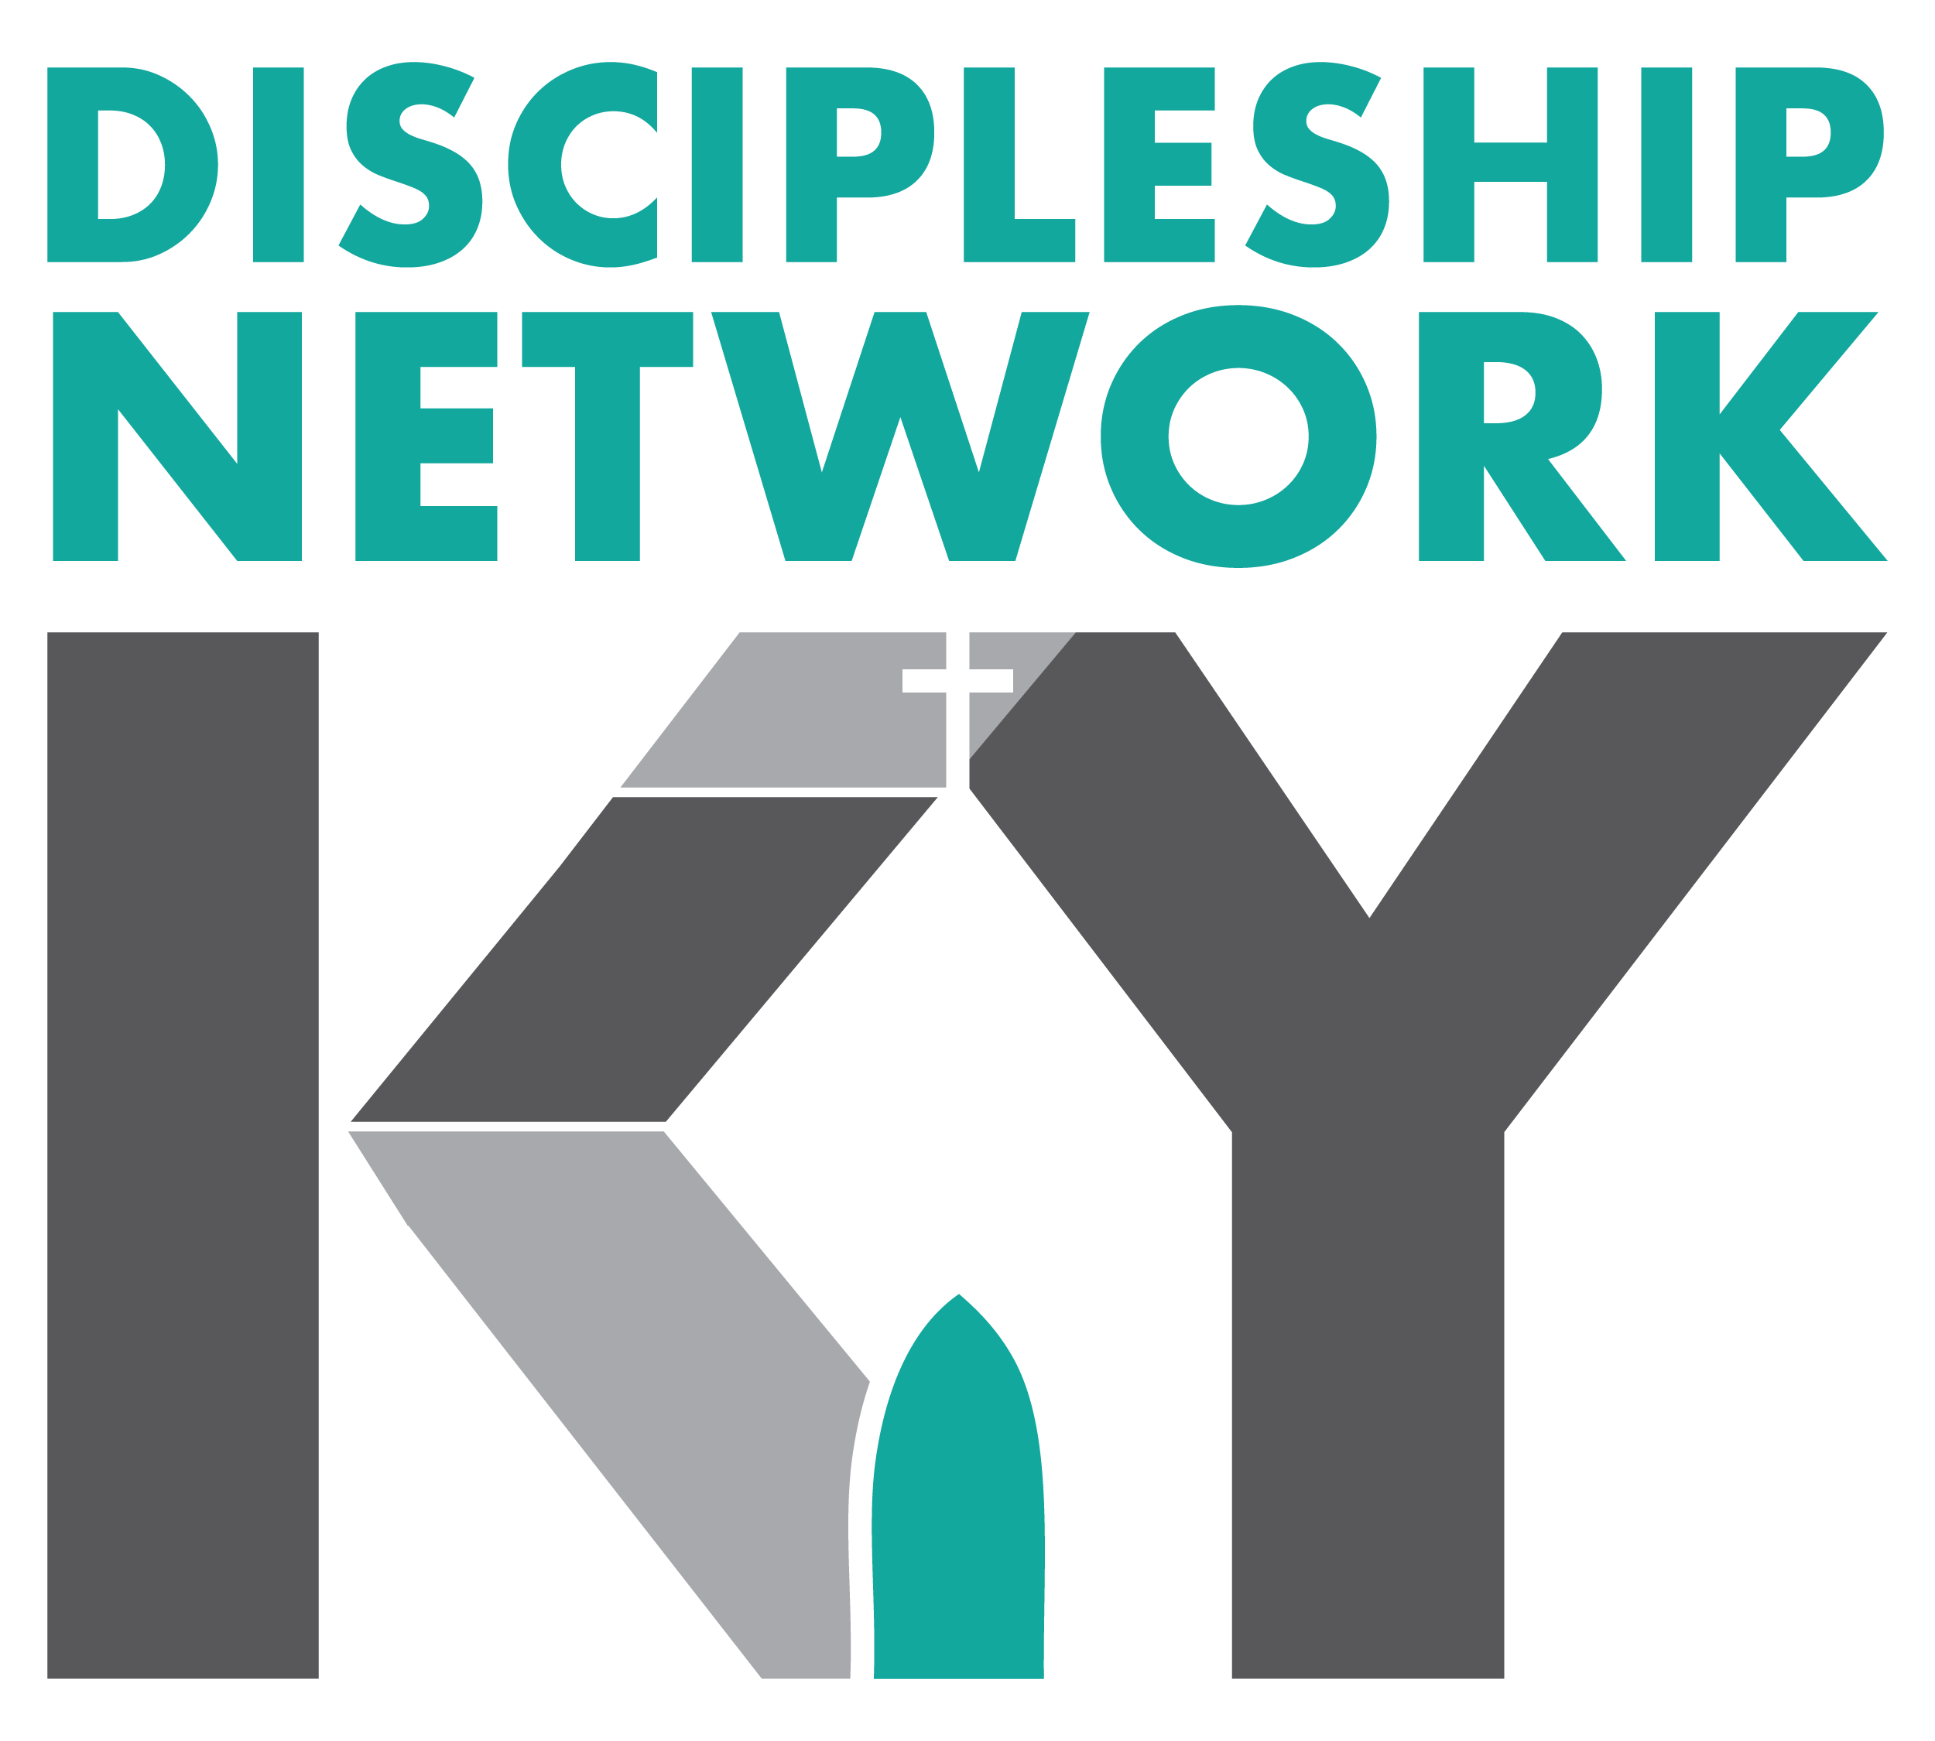
2020-2021 Discipleship Network Officers
President: Bill Ellis
bille@ibclex.com
President-elect: Jamie Coomer
jcoomer@loneoakfbc.org
Secretary/Treasurer: Jeff Smith
jsmith@hurstbournebc.org
KBC Discipleship Consultant: Darryl Wilson
darryl.wilson@kybaptist.org

About – The Discipleship Network of Kentucky is a network of people committed to serving Jesus Christ through the making of disciples.
Mission – Our mission is to connect disciple-makers and provide avenues to share ideas and thoughts that will assist individuals and churches in making disciples of Jesus Christ.
Vision – To see disciple-makers come together in regional events, monthly network lunches, webinars, and statewide events that will provide information, encouragement, and build relationships.
Membership – The annual membership dues help pay for honorariums, materials, and other expenses related to the regional and statewide events each year. The annual dues are $25 (students - $10) per calendar year.
Becoming a member – Please send your name, position (optional), church (optional), address, email, phone number, and annual dues to Jeff Smith, Discipleship Network of KY Secretary/Treasurer, at Hurstbourne Baptist Church, 8800 Shelbyville Road, Louisville, KY 40222
-------------------------------------------------------------------------------------------------------------------------------------------------
Yes, I want to join the Discipleship Network of Kentucky. I understand that I will be added to the email list and will get information pertaining to upcoming Discipleship Network events, discipleship trends, discipleship materials, and how to promote and encourage discipleship among believers.

Name
Position (optional)
Church (optional)
Address
Email Phone

Circle one: Regular Member - $25 per year Student Member - $10 per year

