Go to https://ky.sbcworkspace.com/account/login

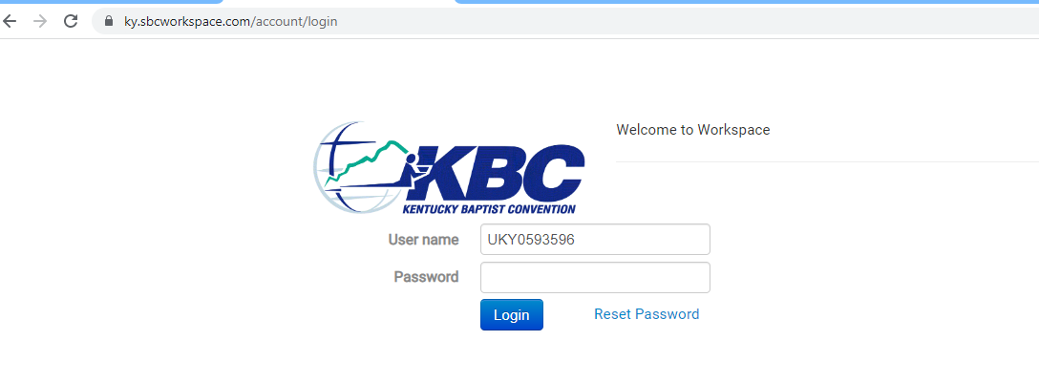
Input User Name
Password
Select Login

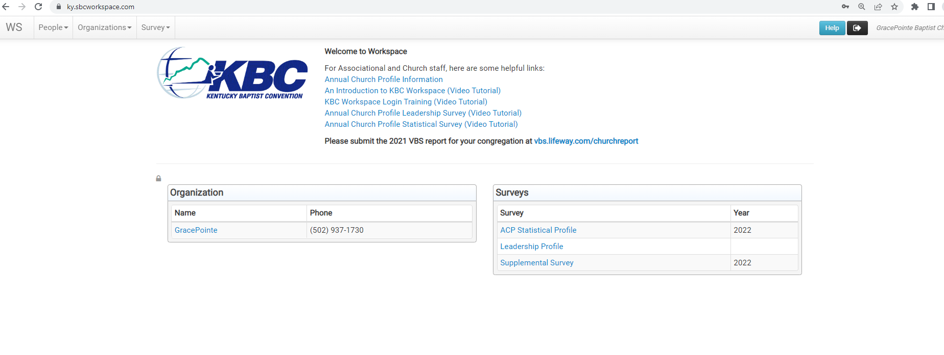
This is your church dashboard

At the top:

WS – Dashboard Page
Person – search for a person
Organization – search for an organization
Survey – search for surveys

WS Dashboad:

Under Welcome to Workspace helpful links on how to use workspace and complete surveys

Under organization it will have your church
Under Surveys it will have the surveys available at this time that have not been closed (if you need to see a closed survey you can do this by going to the survey tab at the top)

Select you church name in the organization box

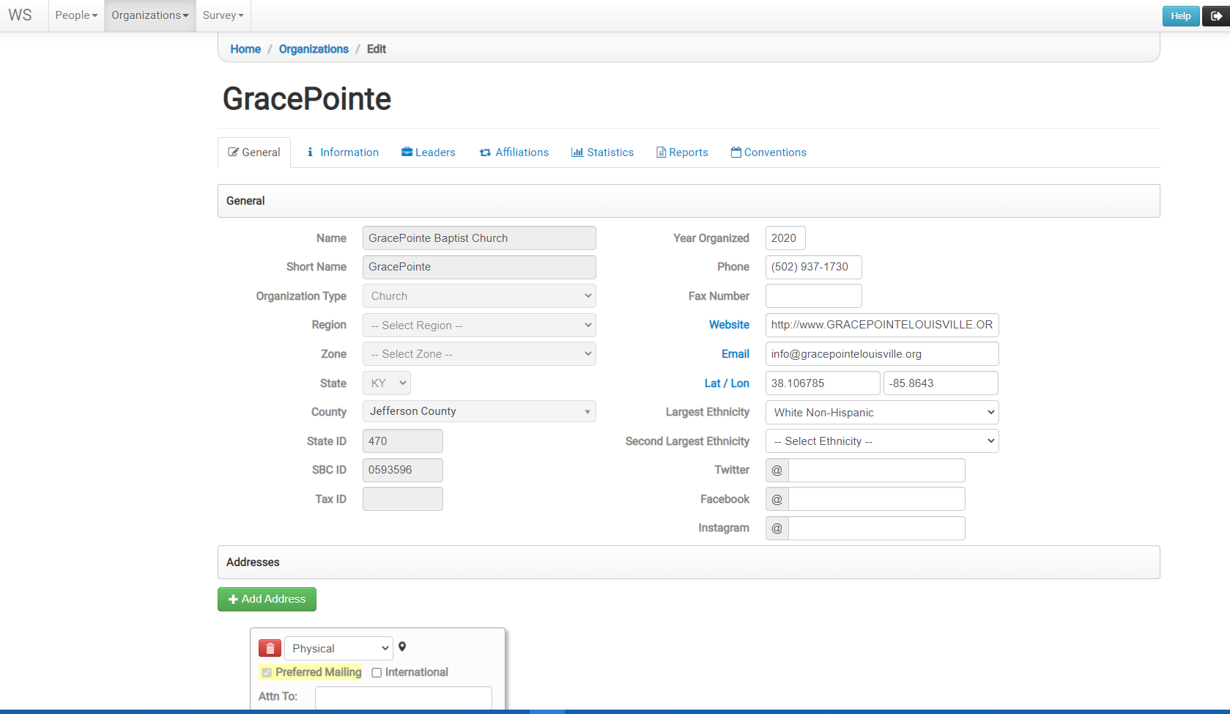

This takes you to your church pages

General – all information about your church
Make sure to update and watch the following
- Phone
- Fax Number
- Website
- Email
- Addresses
  - Physical
  - Mailing

Select the Leaders tab
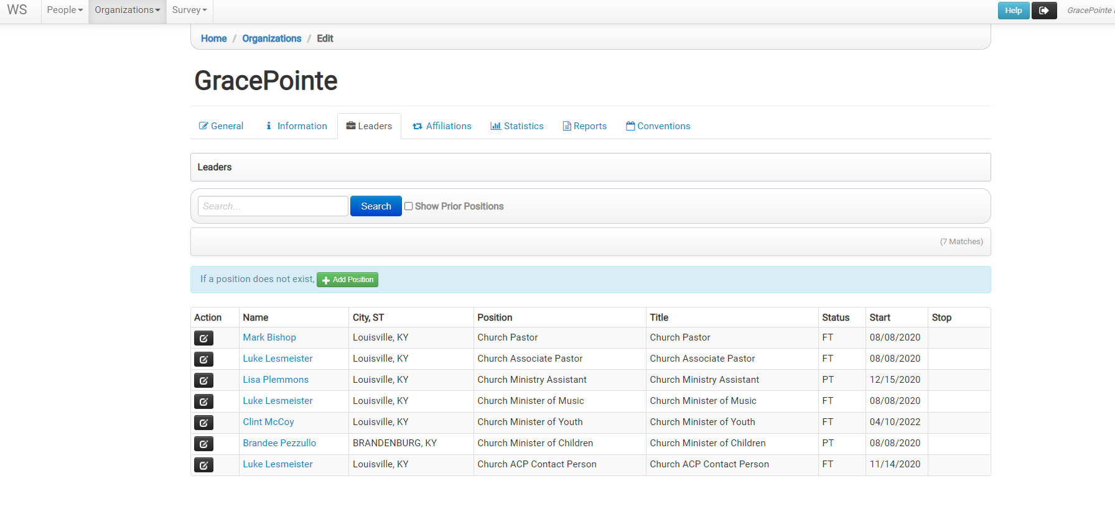
This will show you all your current leaders. If someone is no longer in that position select the black pencil button in front of their name.

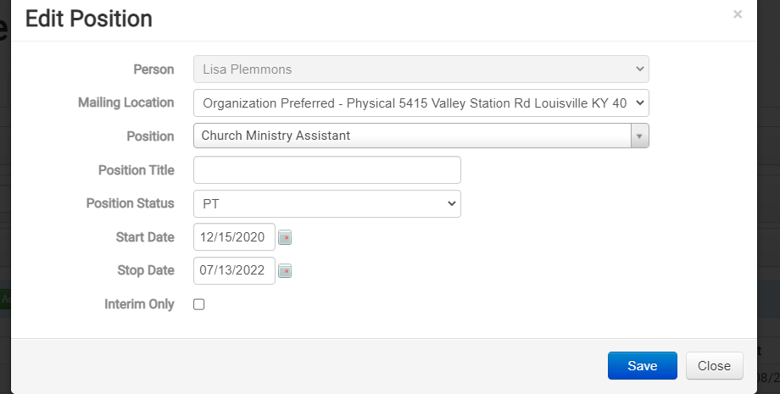
Put a stop date and hit save. This will remove them from your current list.

If you select the Show Prior Positions next to the search button it will show you anyone that was previously in positions. Those in gray are previous position and you will see they have a stop date.

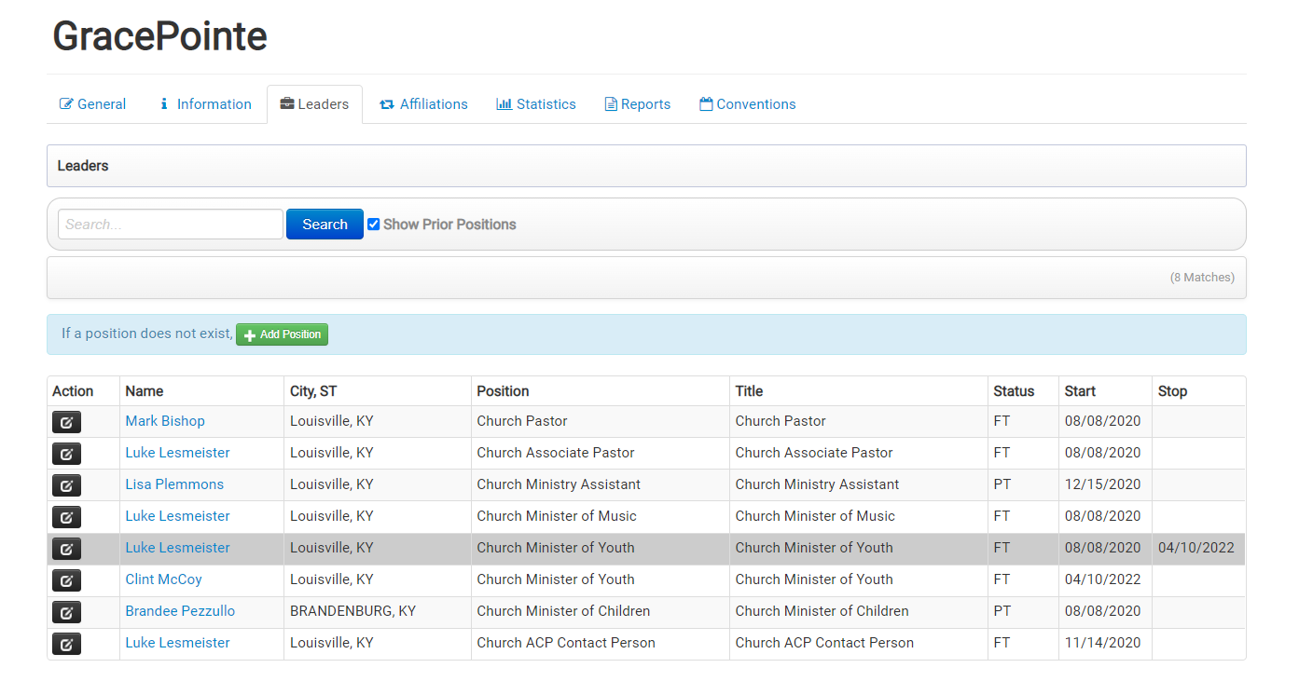

Once you make sure everyone that is currently showing is correct you can add anyone that needs to be added.

Select the green Add Position
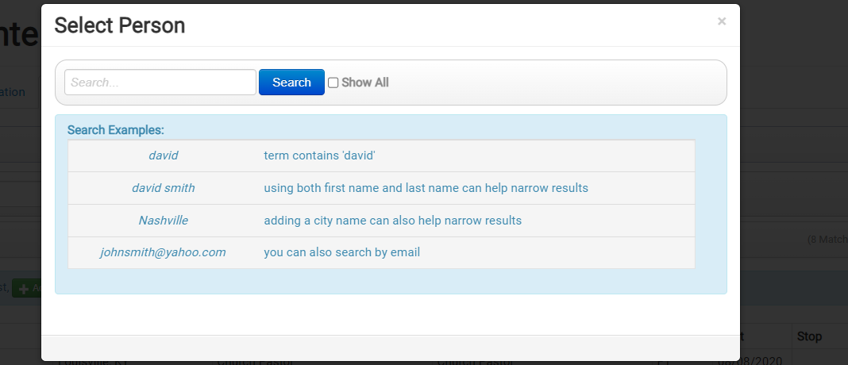

Search for the person you need to add and select search

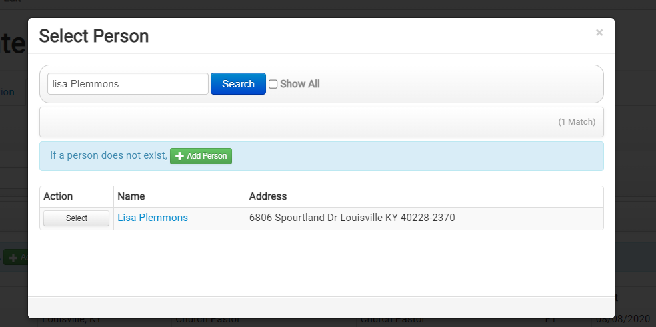

See if any of the names that pull are the person you need to add. If so select that person (you will then complete the add position process)

If the person is not in the box select the add person

Example of adding a person
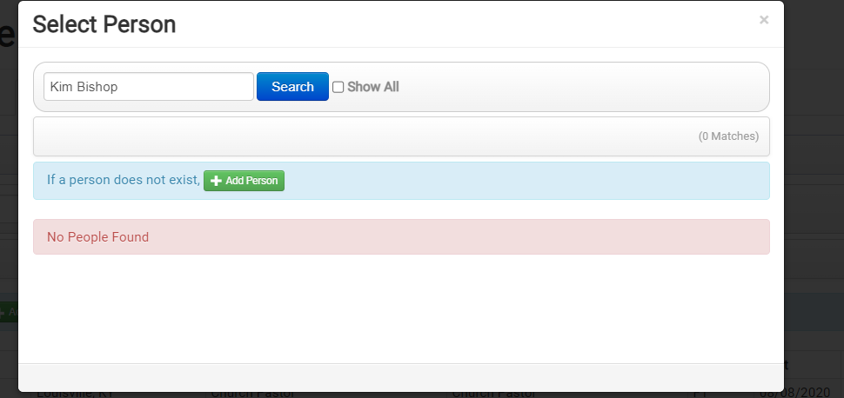
Select Add Person

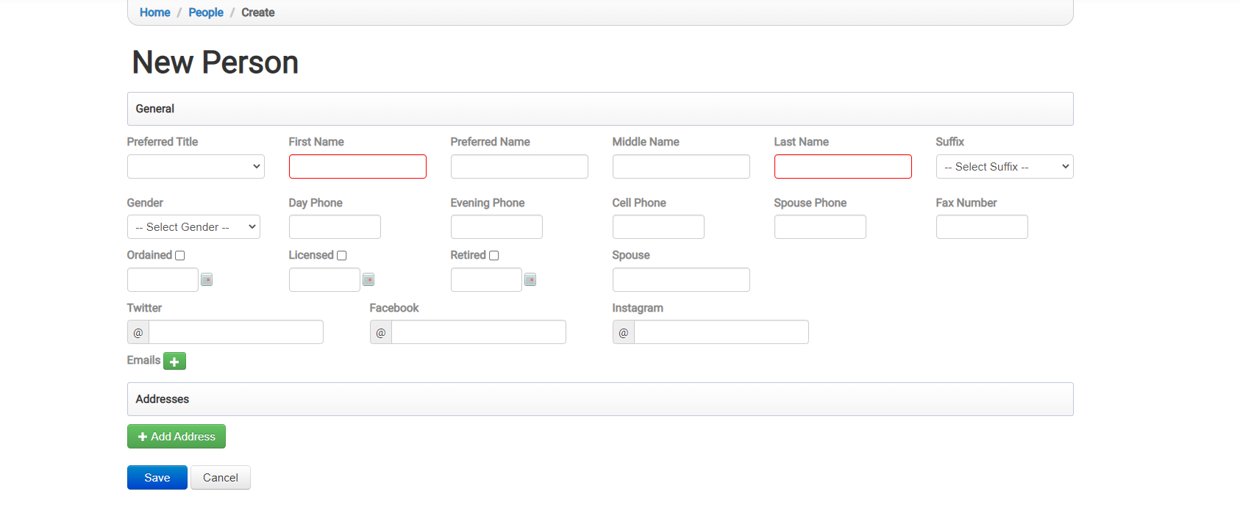Fill in all information you have
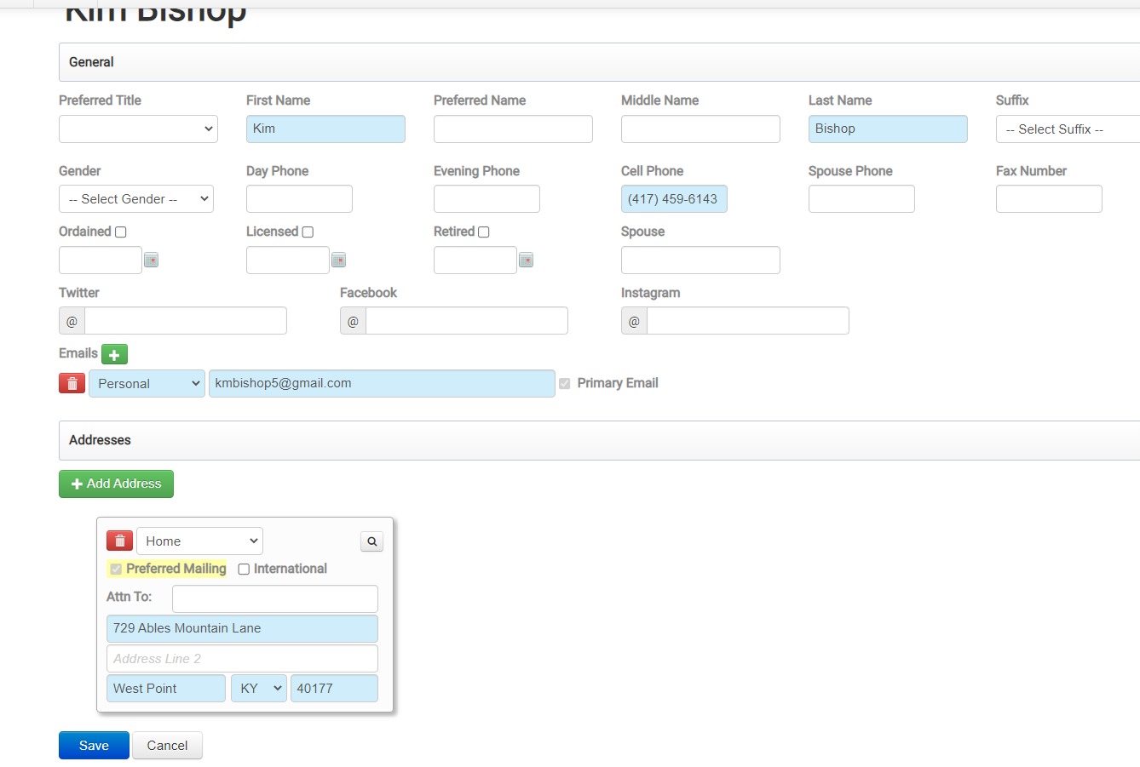

Select Save
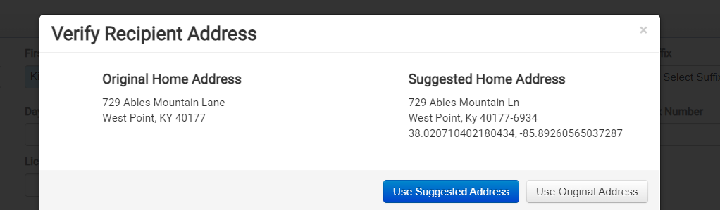

Select Use Suggested Address if Available if not select Use Original Address

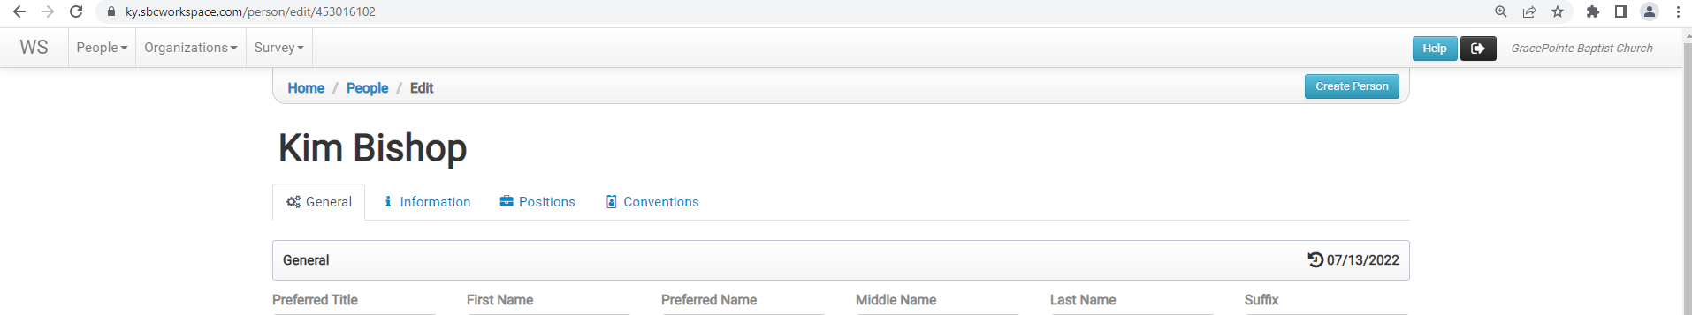Go to top of screen and select WS

Select you church name in the organization box

This takes you to your church pages
Select Leaders
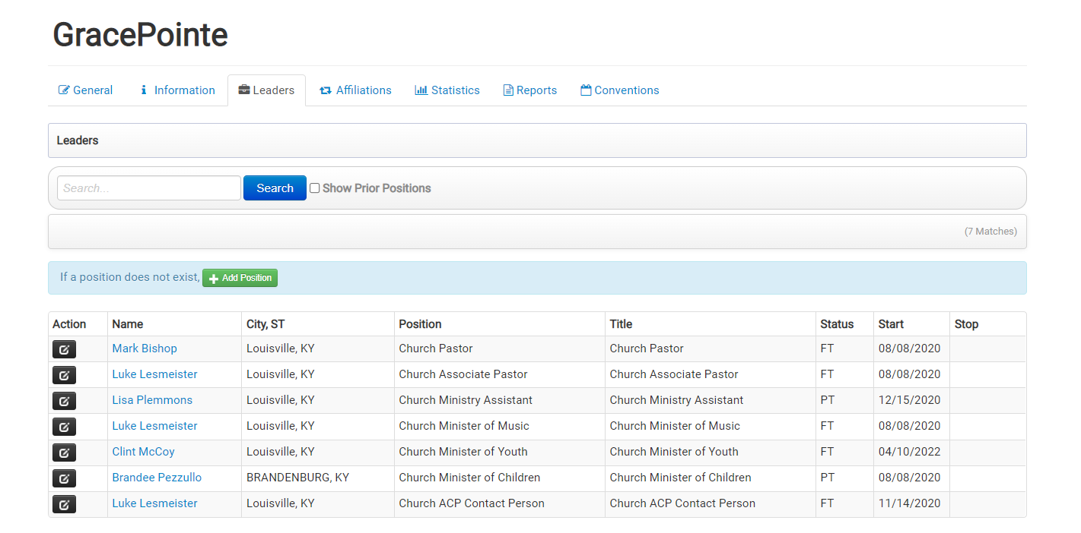

Now select Add Position
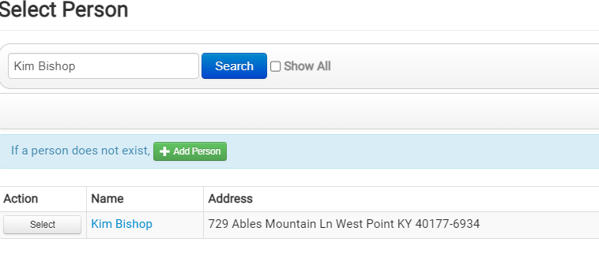
In Search box insert the name of the person you just added to the system. Now when you select search their name should show at the bottom and hit select by their name
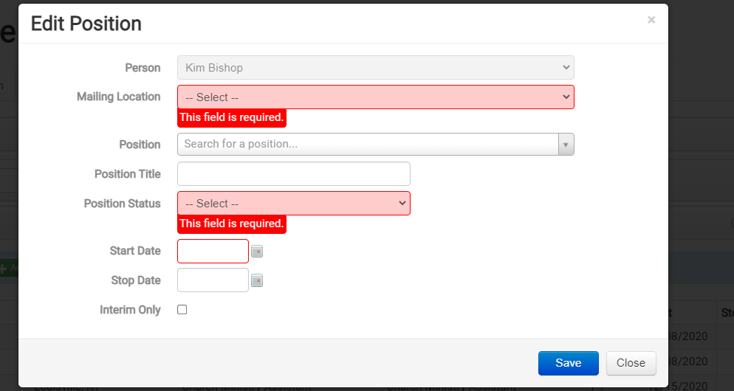

Select the mailing location for the mail for this person
It will either be the organization preferred or person preferred (this is where all mail will be sent for the position)

Position find the position the person is in

Position Status
VO – Volunteer
BI – Bi-Vocational (this is mostly for pastors/music minister etc)
PT – Part-Time
FT – Full-Time

Start Date

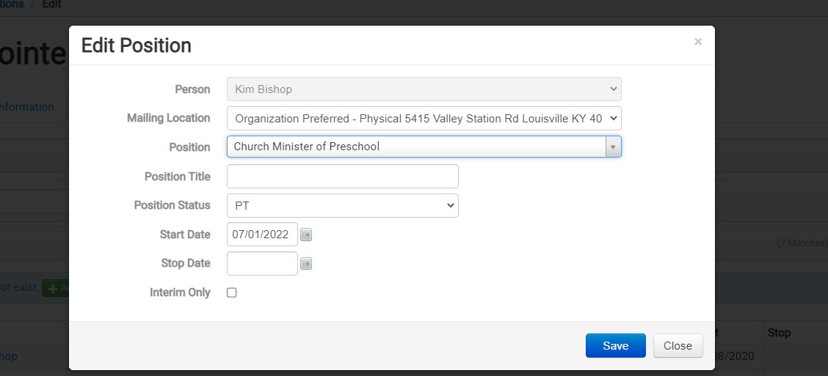
Select Save

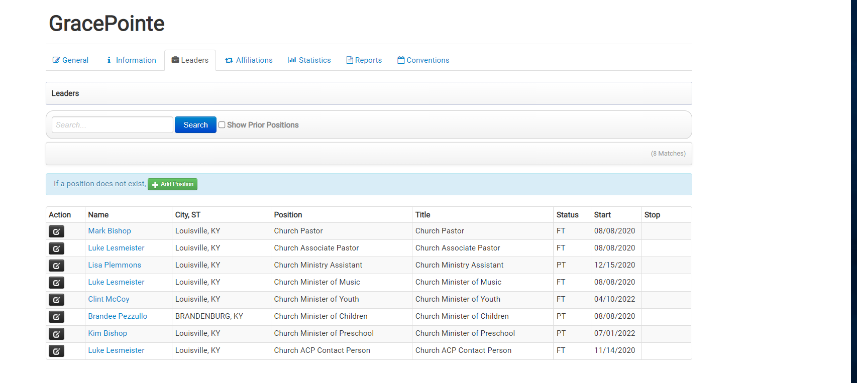
The new person will now show in your leaders list.

