Go to https://ky.sbcworkspace.com/account/login

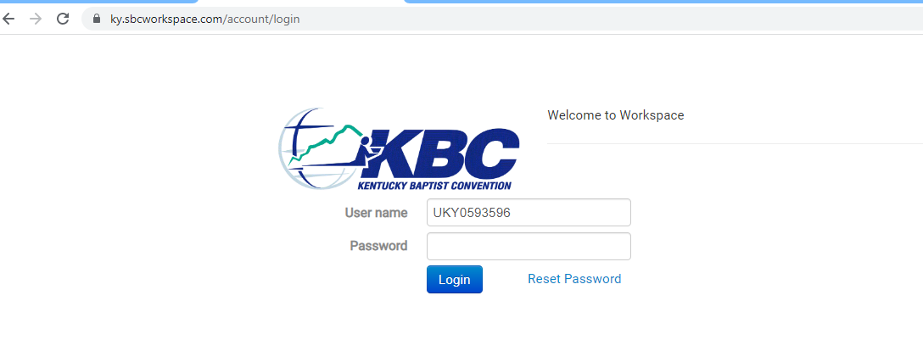
Input User Name
Password
Select Login

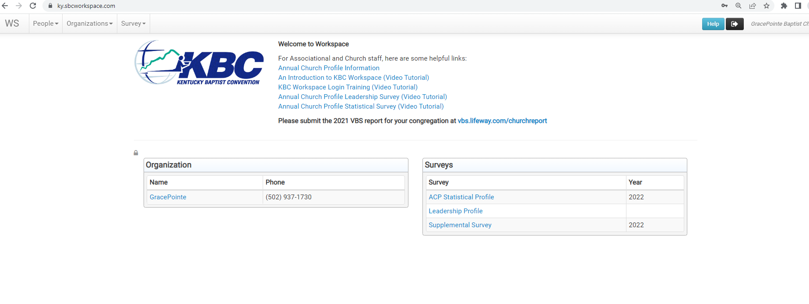
This is your church dashboard

At the top:

WS – Dashboard Page
Person – search for a person
Organization – search for an organization
Survey – search for surveys

WS Dashboad:

Under Welcome to Workspace helpful links on how to use workspace and complete surveys

Under organization it will have your church
Under Surveys it will have the surveys available at this time that have not been closed (if you need to see a closed survey you can do this by going to the survey tab at the top)

Select you church name in the organization box

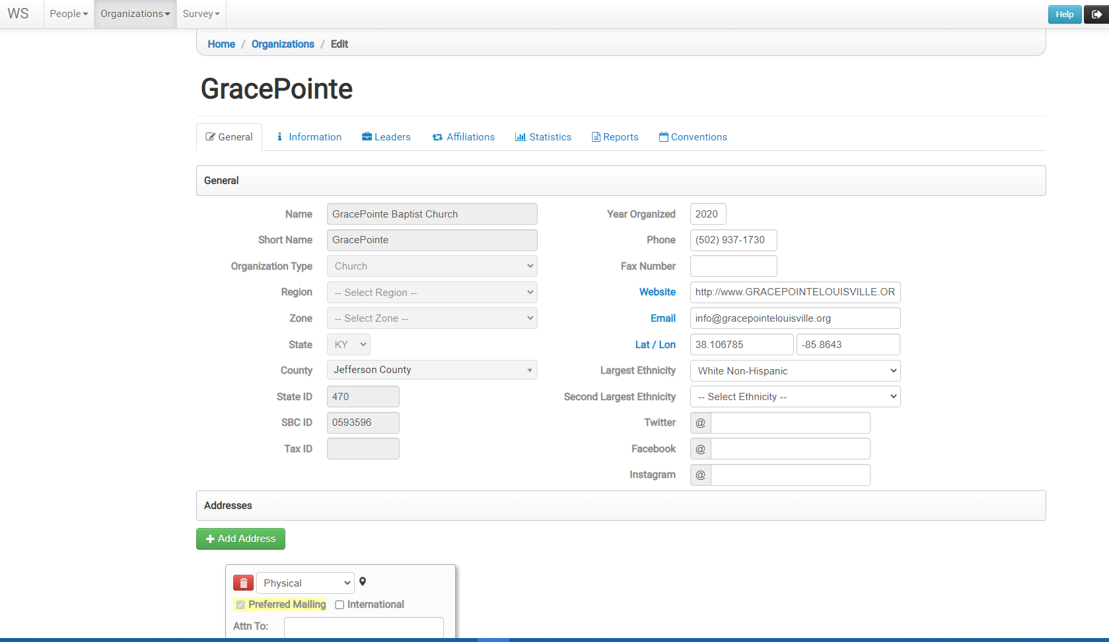

This takes you to your church pages

General – all information about your church
Make sure to update and watch the following
- Phone
- Fax Number
- Website
- Email
- Addresses
  - Physical
  - Mailing
Select Reports
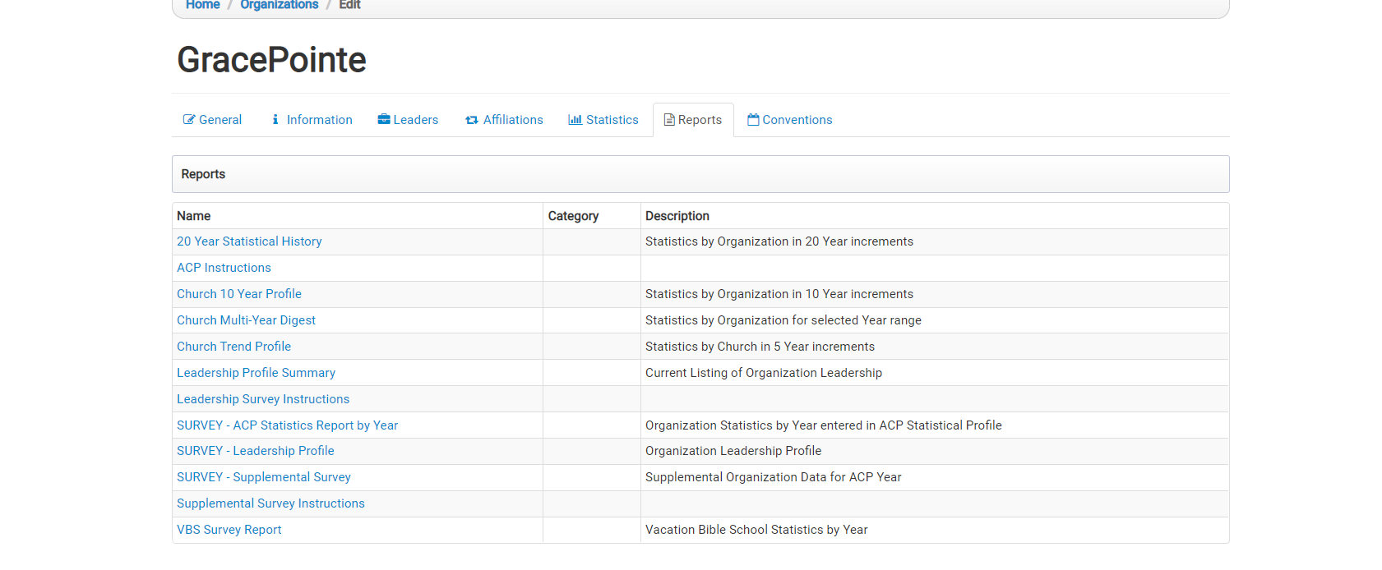

This is a list of predefined reports for your organization

Take a look at each of the reports to see what all information you can get.

